Placing a vSwitch in Promiscuous Mode

1. Log into ESXi and Select Configuration

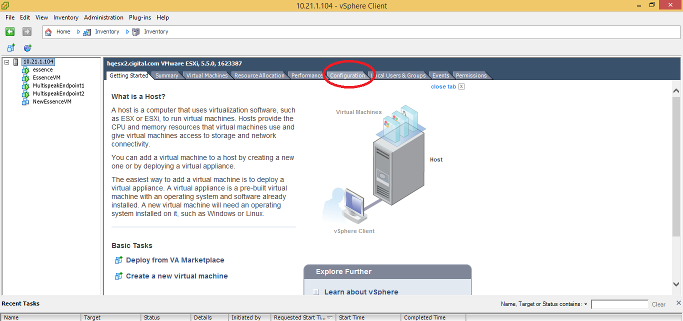

1. Select the Networking link

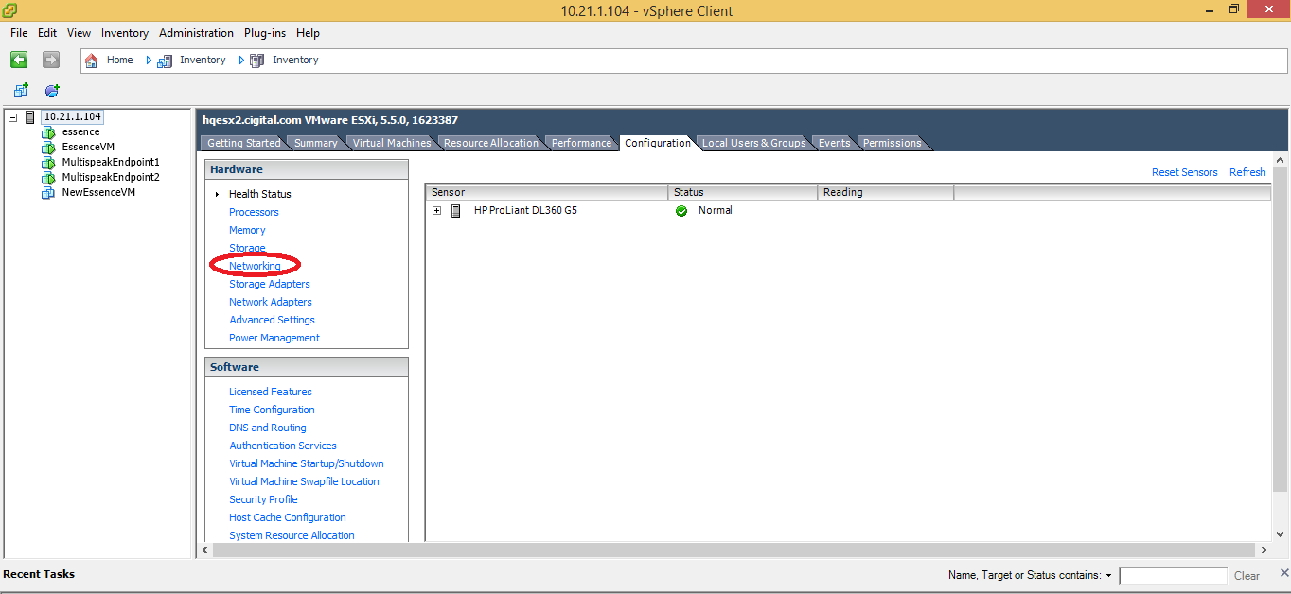

1. Select Properties of the NIC that you wish to configure for the Essence VM

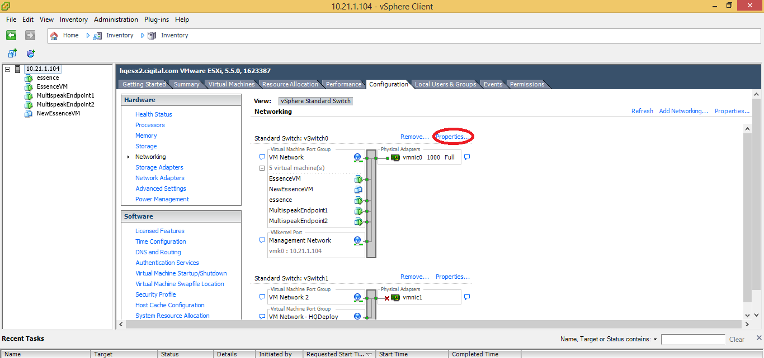

1. Select the vSwitch and click the Edit button

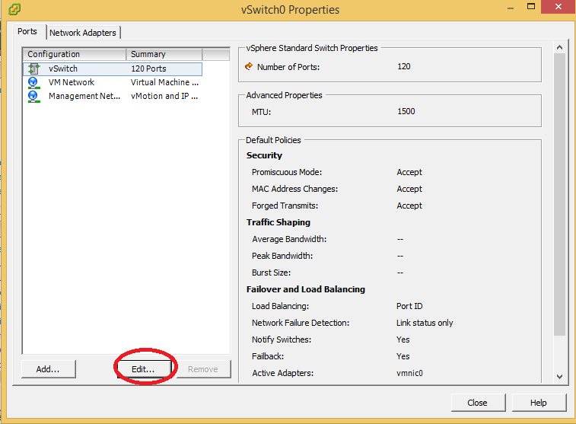

1. Go to the Security tab and ensure Promiscuous Mode is set to ‘Accept’

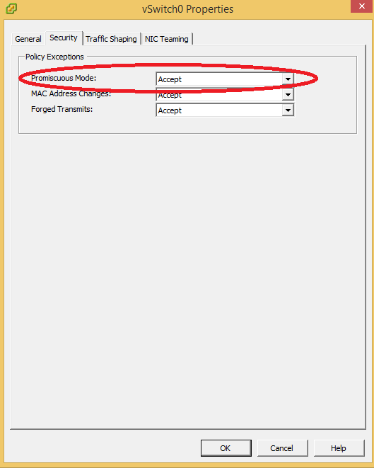

1. Select the VM Network and click Edit

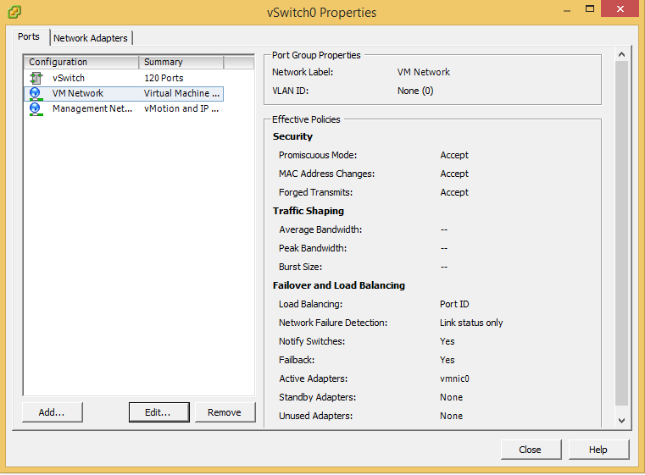

1. Go to the Security tab and ensure Promiscuous Mode is set to ‘Accept’

